RESOLUTION NUMBER 2020-51
A RESOLUTION OF THE PLANNING COMMISSION OF THE CITY OF MORENO VALLEY, CALIFORNIA, RECOMMENDING THAT THE CITY COUNCIL APPROVE CHANGE OF ZONE PEN20-0067 TO AMEND THE CITY ZONING ATLAS FROM RESIDENTIAL 5 (R5) DISTRICT TO RESIDENTIAL SINGLE-FAMILY 10 (RS10) DISTRICT FOR THE PROPERTY LOCATED ON THE SOUTH SIDE OF IRIS AVENUE EAST OF PERRIS BOULEVARD (APN 312-020-025)
WHEREAS, the City of Moreno Valley (“City”) is a general law city and a municipal corporation of the State of California; and
WHEREAS, Passco Pacifica LLC., (“Developer”) has filed an application for the approval of Change of Zone PEN20-0067 (“Application”) requesting a Change of Zone changing the City’s Zoning Atlas from Residential 5 (R5) District to Residential Single-Family 10 (RS10) District for the property located on the south side of Iris Avenue east of Perris Boulevard (APN 312-020-024) (“Site)”; and
WHEREAS, pursuant to the provisions of Section 9.02.200 (Public Hearing and Notification Procedures) of the Moreno Valley Municipal Code and Government Code section 65905, a public hearing was scheduled for November 12, 2020, and notice thereof was duly published and posted, and mailed to all property owners of record within 600 feet of the Site; and
WHEREAS, on November 12, 2020 a duly noticed public hearing was conducted by the Planning Commission where the item was continued to the December 10, 2020 Planning Commission meeting; and
WHEREAS, on December 10, 2020, in accordance with the provisions of the California Environmental Quality Act (CEQA) and CEQA Guidelines, the Planning Commission considered and recommended that the City Council approve Resolution 2020-49.
NOW, THEREFORE, THE PLANNING COMMISSION OF THE CITY OF MORENO VALLEY, CALIFORNIA, DOES HEREBY RESOLVE AS FOLLOWS:
Section 1. Recitals and Exhibits
That the foregoing Recitals and attached exhibits are true and correct and are hereby incorporated by this reference.
Section 2. Notice
That pursuant to Government Code section 66020(d)(1), notice is hereby given that the proposed project is subject to certain fees, dedications, reservations and other exactions as provided herein.
Section 3. Evidence
That the Planning Commission has considered all of the evidence submitted into the administrative record for the General Plan Amendment, including, but not limited to, the following:
- Moreno Valley General Plan and all relevant provisions contained therein;
- Title 9 (Planning and Zoning) of the Moreno Valley Municipal Code and all relevant provisions referenced therein;
- The Change of Zone to change the City’s Zoning Atlas from Residential 5 (R5) District to Residential Single-Family (RS10) District and all other relevant provisions contained therein as shown on Exhibit A;
- Application for the approval of a Change of Zone PEN20-0067 and all documents, records and references contained therein;
- Staff Report prepared for the Planning Commission’s consideration and all documents, records and references related thereto, and Staff’s presentation at the public hearing;
- Testimony and/or comments from Applicant and its representatives during the public hearing; and
- Testimony comments and/or correspondence from all persons that were provided in written format or correspondence, at, or prior to, the public hearing.
Section 4. Findings
That based on the foregoing Recitals and the Evidence contained in the Administrative Record as set forth above, the Planning Commission hereby finds as follows:
(a) The proposed Change of Zone is consistent with the existing goals, objectives, policies and programs of the General Plan;
(b) The proposed Change of Zone will not adversely affect the public health, safety or general welfare; and
(c) The proposed Change of Zone is consistent with the purposes and intent of Title 9.
Section 5. Approval
That based on the foregoing Recitals, Evidence in the Administrative Record and Findings, as set forth herein, the Planning Commission hereby recommends that the City Council approve Change of Zone PEN20-0067 attached hereto as Exhibit A.
Section 6. Repeal of Conflicting Provisions
That all the provisions as heretofore adopted by the Planning Commission that are in conflict with the provisions of this Resolution are hereby repealed.
Section 7. Severability
That the Planning Commission declares that, should any provision, section, paragraph, sentence or word of this Resolution be rendered or declared invalid by any final court action in a court of competent jurisdiction or by reason of any preemptive legislation, the remaining provisions, sections, paragraphs, sentences or words of this Resolution as hereby adopted shall remain in full force and effect.
Section 8. Effective Date
That this Resolution shall take effect immediately upon the date of adoption.
Section 9. Certification
That the Secretary of the Planning Commission shall certify to the passage of this Resolution.
PASSED AND ADOPTED THIS _____ day of __________, 2020.
CITY OF MORENO VALLEY
PLANNING COMMISSION
____________________
Patricia Korzec, Chairperson
ATTEST:
_________________________
Patty Nevins,
Planning Official
APPROVED AS TO FORM:
_________________________
Steven B. Quintanilla,
Interim City Attorney
Exhibits:
Exhibit A Proposed Zoning Map

Exhibit A

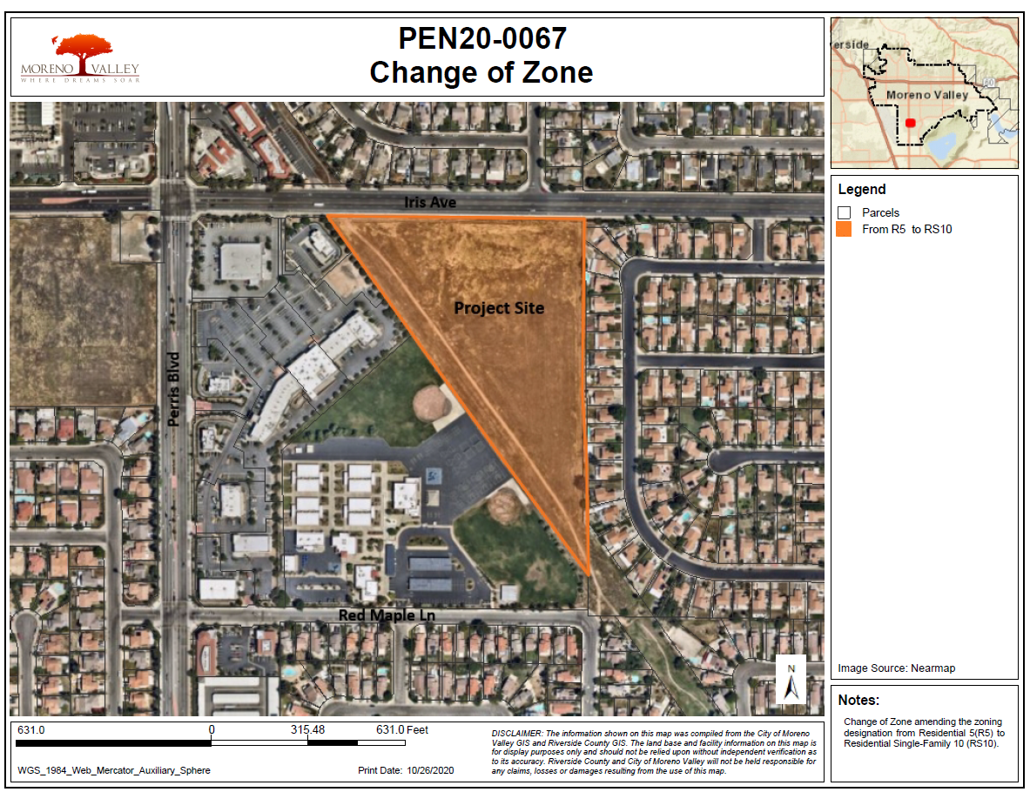

Public Resources Code §§ 21000-21177
14 California Code of Regulations §§15000-15387

